May 2021
Student Recruitment Social Media Posts:

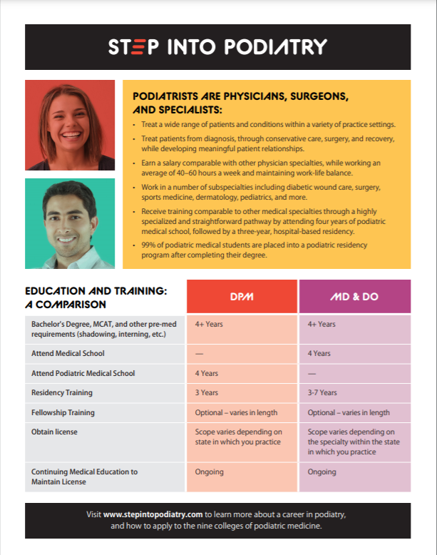

Step into Podiatry brochures promoting the profession are available to download and print in the Student Recruitment Toolkit available at apma.org/toolkit. Print your copies today to keep on-hand in your office to share with interested patients, or take with you to your next career presentation at your alma mater or local high school!

#todayspodiatrist #operatelikeaDPM #stepintopodiatry #podiatry #podiatrist #physician #surgeon #podiatrylife #surgeonsofinstagram #doctorsofinstagram #podiatrystudent #podiatryschool #podiatrystudentlife #futurepodiatrist

Please note: this is intended for member-facing social media.

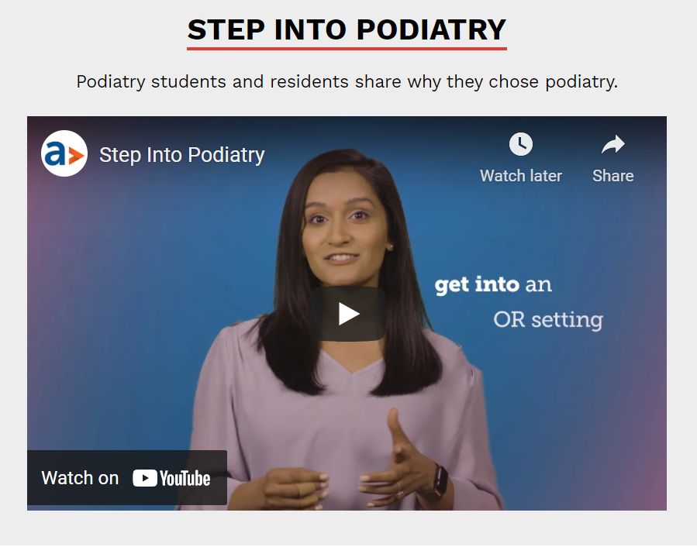
Please note: the embed link is available at: https://www.youtube.com/watch?v=3khopiGYH8c&t=1s or just link directly to the video on YouTube.
There are limitless career options in podiatry including a wide variety of patient types, practice settings, and sub-specialties. Watch the future of our growing profession share what they love about podiatry; StepIntoPodiatry.com has all the details you need to get started on your health-care career.
#podiatry #todayspodiatrist #operatelikeaDPM #stepintopodiatry #podiatrist #physician #surgeon #podiatrylife #surgeonsofinstagram #doctorsofinstagram #podiatrystudent #podiatryschool #medlife #medschool #premed #premedstudent #premedmotivation #podiatrystudentlife #futurepodiatrist #futuredoctor #futuresurgeon #aspiringdoctor #medschool #womeninmedicine #medschoollife #medicalstudent #doctortobe #surgeontobe #careersinmedicine



Is a career in podiatry right for you? Our short quiz helps you give thought to a couple different elements of your future medical career, like the types of patients you would like to see or conditions you’d like to treat. Visit stepintopodiatry.com to take the quiz and determine if podiatry is right for you!

#podiatry #todayspodiatrist #operatelikeaDPM #stepintopodiatry #podiatrist #physician #surgeon #podiatrylife #surgeonsofinstagram #doctorsofinstagram #podiatrystudent #podiatryschool #medlife #medschool #premed #premedstudent #premedmotivation #podiatrystudentlife #futurepodiatrist #futuredoctor #futuresurgeon #aspiringdoctor #medschool #womeninmedicine #medschoollife #medicalstudent #doctortobe #surgeontobe #careersinmedicine
Please note: the direct link to the quiz is https://www.stepintopodiatry.com/is-podiatry-right-for-me/is-podiatry-right-for-you-take-the-quiz/.

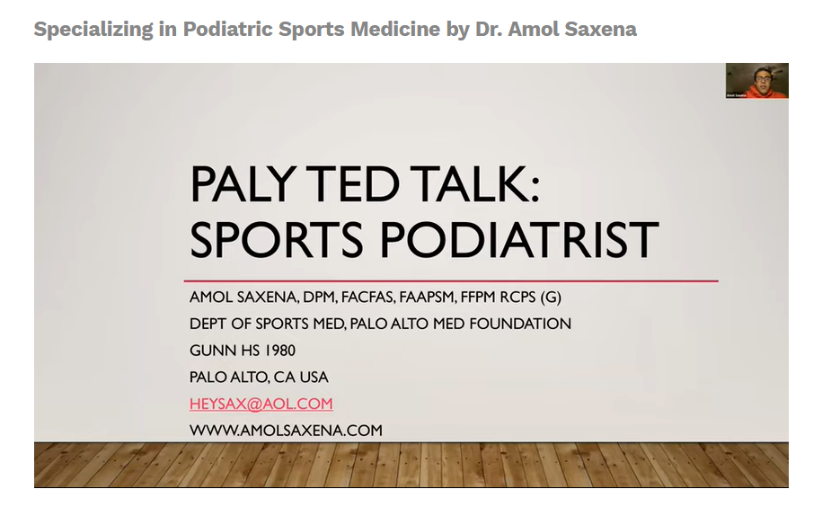

Interested in a career in sports medicine? Check out Dr. Amol Saxena’s presentation on becoming a Sports Podiatrist. Sports medicine is just one of the many sub-specialties offered within podiatry and affords the ability to work with a number of different sports professionals. Dr. Saxena’s presentation is available at stepintopodiatry.com/webinars.

#podiatry #todayspodiatrist #operatelikeaDPM #stepintopodiatry #podiatrist #physician #surgeon #podiatrylife #sportsmedicine #sportsinjury #sportsperformance #surgeonsofinstagram #doctorsofinstagram #podiatrystudent #podiatryschool #medlife #medschool #premed #premedstudent #premedmotivation #podiatrystudentlife #futurepodiatrist #futuredoctor #futuresurgeon #aspiringdoctor #medschool #womeninmedicine #medschoollife #medicalstudent #doctortobe #surgeontobe #careersinmedicine

