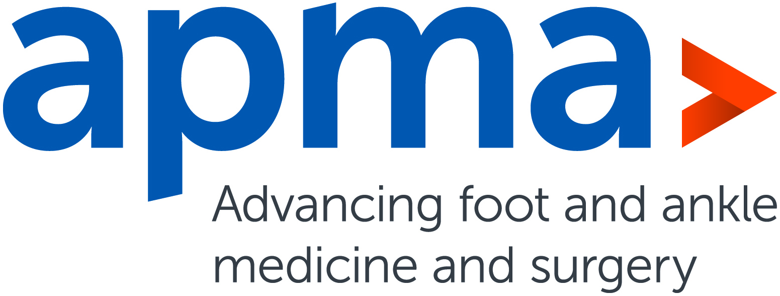

November 12, 2019

"Wound Care Podiatrist Scholarship" Application

HMP Global (HMP) and the North American Center for Continuing Medical Education (NACCME), executors of the annual Symposium on Advanced Wound Care (SAWC) Spring and Fall meetings, are again offering our Wound Care Podiatrist Scholarship. The scholarship is open to any member of the American Podiatric Medical Association (APMA) who has demonstrated exceptional clinical skills and an intense dedication to caring for patients with wounds.

The application criteria for the 2020 SAWC Spring Wound Care Podiatrist Scholarship are listed below. Please submit your completed application to Dyane E. Tower, DPM, MPH, MS, APMA director of Clinical Affairs at detower@apma.org by December 20, 2019. The winner will receive a complimentary registration (value of $500) to attend the 2020 SAWC Spring meeting being held from May 13–17 in San Diego. The winner will be responsible for their travel and hotel costs.

The winner will be presented their framed scholarship certificate award at the start of the SAWC Spring Poster Reception on Friday, May 15, 2020, at 7:15 p.m., in Hall F at the San Diego Convention Center. We’re asking that an APMA officer and winner check in by 7 p.m. prior to the ceremony start and be available to have photos taken afterwards. Applicants must confirm that they are available to attend the San Diego meeting should they be chosen.

Applicant Information:

Name ___________________________________________________________
Title ____________________________________________________________
Facility __________________________________________________________
Address _________________________________________________________
City/State/Zip _____________________________________________________
Phone ___________________________________________________________
Email ___________________________________________________________

Years Practicing Wound Care (number) ________________________________
Wound Care Honors (please list) _____________________________________
Clinical Commendations (please list) __________________________________
Recommendations (please list) ______________________________________

Brief Statement (limit to 250 or 500 words) please state why the scholarship would benefit you

